### FINGERPRINT-BASED VOTING SYSTEM USING BLOCKCHAIN

**MAJOR-PROJECT REPORT**

**Submitted to**



**JAWAHARLAL NEHRU TECHNOLOGICAL UNIVERSITY HYDERABAD, KUKATPALLY, HYDERABAD – 500 085.**

in partial fulfillment of the requirements for the award of the degree of

**BACHELOR OF TECHNOLOGY**

**In**

**COMPUTER SCIENCE AND ENGINEERING**

Submitted by

**MOHAMMAD FAREENA BEGUM 20L51A0568** Under the Esteemed guidance of

**MS. LUBNA NOUSHEEN**

**Asst. Professor, Department of CSE**



**DEPARTMENT OF COMPUTER SCIENCE AND ENGINEERING SHADAN WOMEN’S COLLEGE OF ENGINEERING & TECHNOLOGY**

**KHAIRATHABAD, HYDERABAD-500 004.**

**(Approved by AICTE, Affiliated to JNTU Accredited by NAAC B++, Hyderabad)**

**MAY-2024**

**FINGERPRINT-BASED VOTING SYSTEM USING BLOCKCHAIN**

# CERTIFICATE

This is to certify that the Major project Report titled “**FINGERPRINT BASED VOTING SYSTEM USING BLOCKCHAIN**” is being submitted by **“MOHAMMAD FAREENA BEGUM -20L51A0568”** in partial fulfillment of the requirements for the award for the degree of **Bachelor Of Technology in Computer Science and Engineering** to **Jawaharlal Nehru Technological University Hyderabad,** is a record of bonafide work carried out by her under my guidance and supervision during the academic year 2023 – 2024.

The results presented in this Dissertation have been verified and are found to be satisfactory. The results embodied in this report have not been submitted to any other university for the award of any other degree or diploma.

**Ms.Lubna Nousheen, Dr. Mohd Umar Farooq, Ph.D.**

**Asst. Professor Head of the Department**

Department of Computer and Department of Computer and

Science Engineering. Science Engineering.

Shadan Women’s College of Shadan Women’s College of

Engineering and Technology, Engineering and Technology,

Khairatabad - 500004. Khairatabad - 500004.

**JNTUH University Project Viva voice Examination held on**

PRINCIPAL EXTERNAL EXAMINER

**DECLARATION**

I hereby declare that the **Major Project “FINGERPRINT BASED VOTING SYSTEM USING BLOCKCHAIN**” is a record of work done by me in the Department of Computer Science and Engineering, **Shadan Women’s College of Engineering and Technology, Khairatabad** Affiliated to the **Jawaharlal Nehru Technological University Hyderabad,** in partial fulfillment of the requirements for the award of the degree of **Bachelor of Technology in Computer Science and Engineering.**

The results embodied in this thesis have not been submitted to this/any other University for the award of any other degree or diploma.

**MOHAMMAD FAREENA BEGUM 20L51A0568**

# ACKNOWLEDGEMENT

The satisfaction and euphoria of successful completion of any work could be incomplete without mentioning the people who made it possible, whose constant guidance and encouragement crown my efforts with success.

I take this opportunity to express my grateful acknowledgment to The Management,Shadan Women’s College of Engineering and Technology, Khairatabad for their kind encouragement and for granting permission to do this project.

I also express my thanks to **Dr. K. Palani, M.E, Ph.D., Principal of** Shadan Women’s College of Engineering and Technology, Khairatabad for providing infrastructure and facilities.

I also express my thanks to **Dr. Hima Bindu Vice Principal,** Shadan Women’s Collegeof Engineering and Technology, Khairatabad for providing infrastructure and facilities.

I express my sincere gratitude to **Dr. Mohd Umar Farooq, Ph.D., Head of The Department Of CSE,** for his extended help, concern, and persistent encouragement and support.

I wish to express my heartfelt thanks and sincere acknowledgement to my guide Internal **Ms.Lubna Nousheen, Asst. Professor-Computer Science and Engineering,** for his concern and timely help to direct me for every move in this project.

I will be failing in duty if I do not acknowledge with grateful thanks the authors of thereferences and other literature referred in this project.

I finally thank my parents, friends, and relatives who rendered their help directly or indirectly for the completion of this project.

**MOHAMMAD FAREENA BEGUM 20L51A0568**

# TABLE OF CONTENTS

|  |  |  |
| --- | --- | --- |
| **CHAPTER NO.** | **TITLE** | **PAGE NO.** |
|  | **LIST OF FIGURES** | **i** |
|  | **LIST OF SYMBOLS** | **ii-vii** |
|  | **ABSTRACT** | **viii** |
| 1. | **INTRODUCTION** | **1-3** |
|  | 1.1 GENERAL | 1 |
|  | 1.2 OBJECTIVE | 2 |
|  | 1.3 EXISTING SYSTEM | 2 |
|  | 1.3.1 EXISTING SYSTEM DISADVANTAGES | 3 |
|  | 1.4 PROPOSED SYSTEM | 3 |
|  | 1.4.1 PROPOSED SYSTEM ADVANTAGES | 3 |
| 2. | **LITERATURE SURVEY** | **4-6** |
| 3. | **REQUIREMENTS** | **7-8** |
|  | 3.1 GENERAL | 7 |
|  | 3.2 HARDWARE REQUIREMENTS | 7 |
|  | 3.3 SOFTWARE REQUIREMENTS | 7 |
|  | 3.4 FUNCTIONAL REQUIREMENTS | 8 |
|  | 3.5 NON-FUNCTIONAL REQUIREMENTS | 8 |
| 4. | **METHODOLOGY AND MODULES** | **9-11** |
|  | 4.1 GENERAL | 9 |

|  |  |  |
| --- | --- | --- |
|  | 4.2 PROBLEM DEFINITION | 9 |
|  | 4.3 SYSTEM ARCHITECTURE | 10 |
|  | 4.4 METHODOLOGY | 11 |
| 5. | **SYSTEM DESIGN** | **12-20** |
|  | 5.1 GENERAL | 12 |
|  | 5.2 UML DIAGRAMS | 12 |
|  | 5.2.1 USE CASE DIAGRAM | 12 |
|  | 5.2.2 CLASS DIAGRAM | 13 |
|  | 5.2.3 OBJECT DIAGRAM | 14 |
|  | 5.2.4 STATE CHART DIAGRAM | 15 |
|  | 5.2.5 ACTIVITY DIAGRAM | 16 |
|  | 5.2.6 SEQUENCE DIAGRAM | 17 |
|  | 5.2.7 COLLABORATION DIAGRAM | 18 |
|  | 5.2.8 COMPONENT DIAGRAM | 19 |
|  | 5.2.9 DEPLOYMENT DIAGRAM | 20 |
| 6. | **DEVELOPMENT TOOLS** | **21-23** |
|  | 6.1 PYTHON | 21 |
|  | 6.2 HISTORY OF PYTHON | 21 |
|  | 6.3 IMPORTANCE OF PYTHON | 21 |
|  | 6.4 FEATURES OF PYTHON | 22 |
|  | 6.5 LIBRARIES USED IN PYTHON | 23 |
| 7. | **SOFTWARE TESTING** | **24** |

|  |  |  |
| --- | --- | --- |
|  | 7.1 GENERAL | 24 |
|  | 7.2 DEVELOPING METHODOLOGIES | 24 |
|  | 7.3 TYPES OF TESTING | 24 |
|  | 7.3.1 UNIT TESTING | 24 |
|  | 7.3.2 SPECIFICATION TESTING | 24 |
|  | 7.3.3 SYSTEM TESTING | 24 |
| 8. | **IMPLEMENTATION** | **25-27** |
|  | 8.1 GENERAL | 25 |
|  | 8.2 SAMPLE CODE | 25-26 |
|  | 8.3 SNAPSHOTS | 27-28 |
| 9. | **APPLICATIONS & FUTURE ENCHANCEMENT** | **29-32** |
|  | 9.1 GENERAL | 29 |
|  | 9.2 APPLICATIONS | 29 |
|  | 9.3 FUTURE ENCHANCEMENTS | 30 |
| 10 | **CONCLUSION** | **31** |
| 11 | **REFERENCES** | **32** |

## LIST OF FIGURES

|  |  |  |
| --- | --- | --- |
| **FIGURE NO** | **NAME OF THE FIGURE** | **PAGE NO** |
| 5.2.1 | Use Case Diagram | 13 |
| 5.2.2 | Class Diagram | 14 |
| 5.2.3 | Object diagram | 15 |
| 5.2.4 | State Diagram | 16 |
| 5.2.5 | Activity Diagram | 17 |
| 5.2.6 | Sequence Diagram | 18 |
| 5.2.7 | Collaboration diagram | 19 |
| 5.2.8 | Component diagram | 20 |
| 5.2.9 | Deployment diagram | 21 |
| 4.11 | Architecture Diagram | 11 |
| 5.1 | Numpy, Pandas, Matploytib, Scikit Learn | 20 |
| 8.2.1 | Home Page | 27 |
| 8.2.2 | Login Page | 28 |
| 8.2.3 | Voter Page | 29 |
| 8.2.4 | Lagout page | 29 |

### LIST OF SYMBOLS

|  |  |  |  |
| --- | --- | --- | --- |
| **S.NO** | **NOTATION NAME** | **NOTATION** | **DESCRIPTION** |
| 1. | Class |  | Represents a collection of similar entities grouped together. |
| 2. | Association | NAME | Associations represent static relationships between classes. Roles represent the way thetwo classes see each other. |
| 3. | Actor |  | It aggregates several classesinto single  classes. |
| 4. | Aggregation |  | Interaction between thesystem and external environment. |

|  |  |  |  |
| --- | --- | --- | --- |
| 5. | Relation (uses) | Uses | Used for additional process communicatio  n. |
| 6. | Relation (extends) | extends | An Extended relationship is used when one use case is similar to another use case but does a  bit more. |
| 7. | Communication |  | Communication between various usecases. |
| 8. | State |  | State of the process. |
| 9. | Initial State |  | Initial state of the object |

iii

|  |  |  |  |
| --- | --- | --- | --- |
| 10. | Final state |  | Final state of the object |
| 11. | Control flow |  | Represents  vari  ous control flow between the states. |
| 12. | Decision box |  | Represents decision making process from a constraint |
| 13. | Use Case |  | Interaction between the system and external environment. |
| 14. | Component |  | Represents physical modules which is a collection  of  components. |

iv

|  |  |  |  |
| --- | --- | --- | --- |
| 15. | Node |  | Represents physical modules which are a collection of components. |
| 16. | Data Process/State |  | A circle in DFD represents a state or process which has been triggered due to someevent or action. |
| 17. | External entity |  | Represents external entitiessuch as keyboard,sensors,etc. |
| 18. | Transition |  | Represents communication that occurs betweenprocesses. |

v

6

|  |  |  |  |  |
| --- | --- | --- | --- | --- |
| 19. | Object Lifeline |  | Represents the dimensions that communications.the vertical object | |
| 20. | Message |  | Represents exchanged. | message |

**vi**

7

8

**LIST OF ABBREVATION**

|  |  |  |
| --- | --- | --- |
| **S.NO** | **ABBREVATION** | **EXPANSION** |
| 1. | DB | DATA BASE |
| 2. | WB | WEB BROWSER |
| 3. | ANACONDA | ANACONDA PROMPT |
| 4. | MVS | MICROSOFT VISUAL STUDIO |
| 5. | SQL | MICROSOFT SQL |

9

# ABSTRACT

Web Applications are used in the development of the Smart Voting System. Each voter's facial image, fingerprint, and voter ID with blockchain are required by the program in order to guarantee their individuality in the system. The election committee's manual labour is decreased by this system enables easy voting and authenticates the voter to prevent loitering or voting fraud. It guarantees that the voting process cannot be changed by an unauthorized individual. Using gathered data that is kept in a centralized database data, the voter authentication may be done in real time. The suggested dual authentication method employs facial detection as its second level of verification after verifying the fingerprint as its first stage. The security of the voter data is another priority for this smart voting system. By requiring all citizens to register to vote even after being mobilized, this helps to increase the voting rate...

0

**CHAPTERS**

# CHAPTER 1 INTRODUCTION

### GENERAL

In India, we used two types of voting processes. Traditionally we used ballot papers to vote and the votes are counted manually, which consumes excess of time. Then ballot papers are replaced by electronic voting machines as it consumes time to count the votes and due to the error involved in the manual counting process. The electronic voting machine gives quick publication of results which is accurate. In the existing system, there are so many chances to misuse the votes as it does not have proper identification system. In our technique, iris and Finger print are used. Fingerprint is unique for every single person, so that we can avoid bogus voting. But for old person and cancer patients the fingerprint is not clearly visible so we introduced the technique called iris scanning, so that they can cast their votes As we all know India is the largest democratic country, the best form of our government is one which allows the citizen to cast the vote and elect the leader of their choice. The future of our country and fate of citizens all lies in a single vote. Traditionally we used ballot papers to vote and the votes are counted manually, which consume excess of time. Then ballot papers are replaced by electronic voting machine as it consumes large time to count the votes and due to the error involved in the manual counting process. The electronic voting machine gives quick publication of result which is accurate. The one that are temporarily out of their voting stations will have difficulties in casting their votes. The online voting should be adopted, as the current process is not flexible for voter’s convenience, online voting will increase the number of voter’s participation in the election. The proposed system will give trust and confidence to voters that the proposed voting system will provide protection to votes and as well as who cast their votes. In our proposed system, we have altered level of safety in voting process which provides reliable and secure voting. They are iris recognition, finger print and OTP.

### SCOPE OF THE PROJECT

* The Purpose of this project is to conduct an election easily and effectively. Hence, the election will be fair and free from any bad practice.
* This research intends to make an election dynamic. So, any number of candidates can apply for the election.
* This research on “Fingerprint Election System” which is being developed as required for an academic course.
* This research is done to provide a detailed specification of the requirements for the developers.

### OBJECTIVE

System Analysis is the primary stage according to System Development Life Cycle model. This primary begins with the analyst.

The hardware requirement of this project is an external fingerprint sensor i.e. Hamster Pro H20.

The software implementation includes sublime text 3(Version-3207), Microsoft Visual Studio 2019, MySql Server 2008 R2, X-Code(For Testing), Windows Platform.

### EXISTING SYSTEM

Similarly, Thompson et al. found that the amount of visible area in a target print was positively correlated with classification accuracy among novices. Interestingly, this relationship also depended on the source of the print.

Marcon had naïve observers’ rate “high quality” (known prints) and “low quality” latent for distinctiveness. Performance for categorizing pairs of prints as coming from the same source or a different source was higher for high-quality and high-distinctiveness images. Together, these studies show that performance suffers when fingerprint image quality is low, but reveal little about the specific nature of the information that correlates with low or high quality.

### EXISTING SYSTEM DISADVANTAGES

* Far from secure against vote fraud.
* Recount of voting is not possible.
* Expensive to move and store
* Time consuming
* Less security

### PROPOSED SYSTEM

* Finger print and block chain is used for user to authenticate voting mechanism in this corner edge method is used to finger print matching. Whenever any transaction will occur in the system, the record of that transaction is maintained in the form of hash value in a block. Each next block will get attached to the previous block and in this way a virtual block chain will occur. The hash value of a current block is generated using the data of a current block and the hash of the previous block. In this way if any of the block is tempered the subsequent all the block’s hash must be changed. Such multiple copies are maintained at different servers, which will assure the data security and confidentiality. As everything is through the application interface, it will maintain transparency in the voting system

### ADVANTAGES OF PROPOSED SYSTEM:

* Decentralization ensures that no party controls the voting process.
* Transparency throughout the voting process.
* It is tamper-proof.
  1. **GENERAL**

**CHAPTER 2 LITERATURE SERVEY**

A literature survey is a comprehensive review of existing research and publications on a specific topic. It involves summarising and evaluating previous studies to understand current knowledge, identify gaps, and highlight key findings. This helps researchers build on existing work, avoid duplication, and formulate new research questions. A good literature survey presents an organized overview, critically assesses the sources, and provides a foundation for further research. It is an essential step in academic and scientific work, ensuring that new studies are informed by and contribute to the broader body of knowledge.

### LITURATURE SEVEY

* + 1. **Literature Survey on Online Voting System Using Blockchain**

**Authors:** Vaibhav Anasune, Pradeep Choudhary, Madhura Kelapure, Pranali Shirke and Prasad Halgaonkar.

Highly advanced security methods are necessary to introduce effective online voting system in the whole world. The aspect of security and transparency is a threat from global elections with the conventional system. General elections still use a centralized system where one organization manages it. Some of the problems that can occur in traditional electoral systems are with an organization that has full control over the database and system, it is possible to manipulate the database.

* + 1. **A Systematic Literature Review and Meta-Analysis on Scalable Blockchain Based Electronic Voting Systems**

**Authors:** Uzma Jafar, Mohd Juzaiddin Ab Aziz, Zarina Shukur and Hafiz Adnan Hussain

Electronic voting systems must find solutions to various issues with authentication, data privacy and integrity, transparency, and verifiability. On the other hand, Blockchain technology offers an innovative solution to many of these problems. The scalability of Blockchain has arisen as a fundamental barrier to realizing the promise of this technology,

especially in electronic voting. This study seeks to highlight the solutions regarding scalable Blockchain-based electronic voting systems and the issues linked with them while also attempting to foresee future developments. A systematic literature review (SLR) was used to complete the task, leading to the selection of 76 articles in the English language from 1 January 2017 to 31 March 2022 from the famous databases. This SLR was conducted to identify well-known proposals, their implementations, verification methods, various cryptographic solutions in previous research to evaluate cost and time

* + 1. **A Survey of Blockchain-Based on E-voting Systems**

**Authors:** Yousif Osman Abuidris, Rajesh Kumar and Wang Wenyong

Blockchain technology as a decentralized and distributed public ledger in a P2P network has recently gained much attention. In this technology, a linked block structure is applied, and a trusted consensus mechanism is established to synchronize data modifications, making it possible to develop a tamper-proof digital platform for data storage and sharing. We think that blockchain could be used in various interactive online systems, such as the Internet of Things, supply chain systems, voting systems, etc.

* + 1. **Survey on Voting System using Blockchain Technology**

**Authors:** Mayur Shirsath, Mohit Zade, Riteshkumar Talke, Praful Wake and Maya Shelke

The use of information technology has in some ways revolutionized in many sectors. Evoting is said to be a symbol of modern democracy. While research on the topic is still emerging, it has mostly focused on the technical and legal issues instead of taking advantage of this technology and implementing it for good cause. Usefulness of e-voting will perform best when compared with the existing framework. The word Vote means to choose a candidate from a given list of candidates who will lead the organization or the group .The main goal of voting is to practice voting in such a way that every person votes to elect their leader. Most countries in the world, India is no exception, had trouble voting. Voting is still carried out in countries in physical mode. This physical mode process is not safe as it can be manipulated by members of voting commitment. There are many issues such as voting stations being too far and improper voting tools. The proposed flagship internet-based online voting system supported by blockchain technology solves this very problem.

* + 1. **A Survey on Smart Electronic Voting System Using Blockchain Technology Authors:** Naina Nagesh Dhepe and Dr. Pathan Mohd Shafi

India is the world’s largest democracy with a population of more than 1 billion; India has an electorate of more than 668 million and covers 543 parliamentary constituencies. Voting is the bridge between the governed and government. The last few years have brought a renewed focus on to the technology used in the voting process. The current voting system has many security holes, and it is difficult to prove even simple security properties about them. A voting system that can be proven correct has many concerns. There are some reasons for a government to use electronic systems are to increase elections activities and to reduce the elections expenses.

# CHAPTER 3 REQUIREMENTS

### GENERAL

System analysis is a very complex process used by professionals in order to maintain and develop computer-based systems It helps to understand what does a system does and what are its requirement and how it will be maintained, so it’s quite crucial to know and understand users requirement.

The project requires both hardware and software tools. The hardware tools are SecuGen Hu20 Pro. Software components are Windows OS, Sublime Text 3 (version-3.207), Microsoft Visual Studio 2019, MySql Server 2008 R2.

### HARDWARE REQUIREMENTS:

* System : Intel(R) Core(TM) i3-7020U CPU @ 2.30GHz
* Hard Disk : 1 TB.
* Input Devices : Keyboard, Mouse
* Ram : 4 GB.

### SOFTWARE COMPONENTS:

* Operating system : Windows XP/7/10.
* Coding Language : Python
* Tool : Anaconda Interface : Jupiter notebook

### FUNCTIONAL REQUIREMENTS

A functional requirement defines the function of a software system or its components. A functionis described as a set of inputs, the behavior, Firstly, the system is the first that achieves the standardnotion of semantic security for data confidentiality in attribute-based deduplication systems by resorting to the hybrid cloud architecture.

### NON-FUNCTIONAL REQUIREMENTS

**The major Non-functional Requirements of the system are as follows**

**Usability**

The system is designed with a completely automated process hence there is no or less userintervention.

**Reliability**

The system is more reliable because of the qualities that are inherited from the chosen platformpython. The code built by using Python is more reliable.

**Performance**

This system is developed in high-level languages and using advanced back-end technologies it willgive a response to the end-user on the client system with in very little time.

**Supportability**

The system is designed to be cross-platform supportable. The system is supported on a wide rangeof hardware and any software platform, which is built into the system.

**Implementation**

During the implementation of this project have used all the opensource software. We have used

1. Windows Plateform.
2. Microsoft Visual Studio.
3. Microsoft SQL Server 2008.

**CHAPTER 4 METHODOLOGIES AND MODULES**

### GENERAL

As now we all know that till date no more than 67 percent of poll turn around ratio is noted in India. Well, this has happened mainly because India is a vast country with a lot of Career opportunities for its citizen in a different part of-of the country. But due to this, the friction of people living in India have to shift to a different part of the country to earn a livelihood. When the election dates are announced, Legally the people should go to their place where they are registered as voters and cast their votes. But in most of the cases, This does not happen, As this process costs money and time to travel, Which people are not willing to spend. This is the reason the poll turnaround ratio of India has never recorded above 67 percent and in the past 62 years, It has increased only by 4.89 percent. So the main problem is lesser poll turnaround ratio, But this is not the only reason for such lesser poll percentage.

### PROBLEM DEFINITION

Everything we are doing with the comfort of just one click, Then why don’t we vote smartly. This project will help in saving the most precious time of voters and avoiding the long hectic queue of the polling centers and saving money. This project will also reduce the number of Invalid voters cast per election as even one vote can create a difference. We, With the help of this project, aims to achieve a polling turnaround ratio of 80 Percent or ab[ove by 2029. We are also using biometric to identify the person so that one person can’t cast the vote again. This will make democracy even stronger.

## SYSTEM ARCHITECTURE

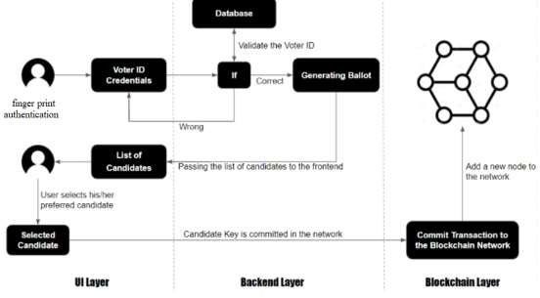

**Figure:4.3 System Architecture**

**The following takes place in Figure:**

Step 1: The election officer sets the booth manager and candidate details. Step 2: Then the Booth manager sets the Voter details and Fingerprint.

Step 3: Verification of voters in Booth.

Step 4: After verification, the voter login page will open.

Step 5: The booth manager identifies how many votes are polled in Booth. Step 6: After a vote is polled the data is stored in the Blockchain database.

Step 7: Then the election is completed. The election result is displayed in the graph by the election officer.

## METHODOLOGIES

### MODULES NAME:

* + 1. Admin Module
    2. User Module

### 4.4.1 MODULES EXPLANATION:

The system has 1 major module and its submodules:

### Admin Module

* 1. **Add Candidate:**

-> Admin can add as many numbers of candidates dynamically who wanna contest the election.

* 1. **Add Election:**

-> System allows admin to add election.

* 1. **View Election:**

-> After creating an election, the admin would be able to see the details of the election except who cast votes to whom.

* 1. **Add Voter:**

-> System allows admin to register voters by scanning their thumb impressions and storing their details in the remote database.

* 1. **View Result:**

-> Post elections admin can view results and can check who won the election.

### User Module

In this project, we are using a public python Blockchain to store and manage voting data as Blockchain provides secure and tamper proof of data storage and to implement this project we have designed following modules. User will register with application using finger print and generate block chain for user using these details user will login and vote to candidate.

# CHAPTER 5 SYSTEM DESIGN

### GENERAL

In order to effectively design and develop a system, it is important to understand and document the requirements of the system. The process of gathering and documenting the requirements of a system is known as requirement analysis. It helps to identify the goals of the system, the stakeholders, and the constraints within which the system will be developed. The requirements serve as a blueprint for the development of the system and provide a reference point for testing and validation.

### UML DIAGRAMS

* + 1. **USE CASE DIAGRAM**

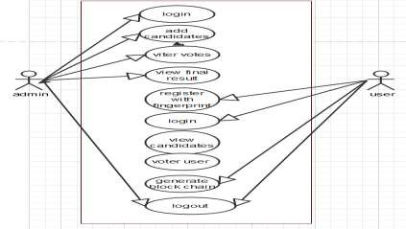

### EXPLANATION:

**Figure 5.2.1 Use Case Diagram**

A use-case diagram in the Unified Modeling Language (UML) is a type of behavioral diagram defined by and created from a Use-case analysis. Its purpose is to present a graphical overview of the functionality provided by a system in terms of actors, their goals (represented as use cases), and any dependencies between those use cases. The main purpose of a use case diagram is to show what system functions are performed for which actor. The roles of the actors in the system can be depicted.

### CLASS DIAGRAM

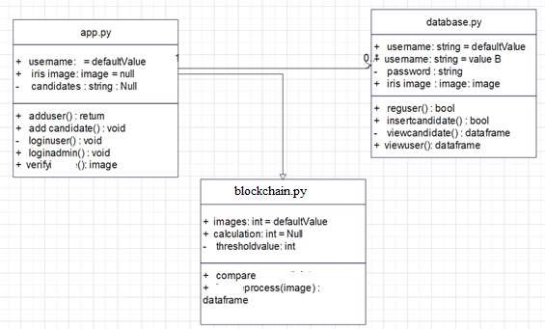

**Figure:5.2.2 Class diagram**

### EXPLANATION

In software engineering, a class diagram in the Unified Modeling Language (UML) is a type of static structure diagram that describes the structure of a system by showing the system's classes, their attributes, operations (or methods), and the relationships among the classes. It explains which class contains information.

### OBJECT DIAGRAM

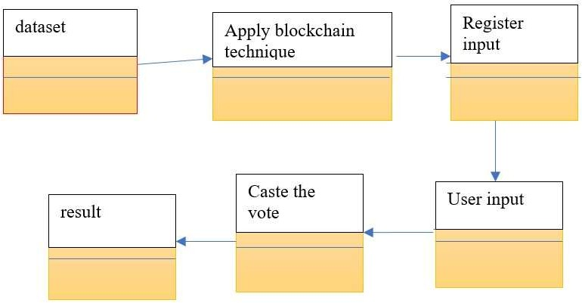

**Figure:5.2.3 Object diagram**

### EXPLANATION

The above diagram tell about the flow of objects between the classes. It is a diagram that shows a complete or partial view of the structure of a modelled system. In this object diagram represents how the classes with attributes and methods are linked together to perform the verification with security.

### STATE DIAGRAM

**LOGIN:**

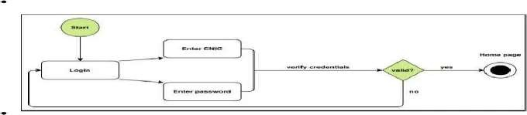

**ADD CANDIDATE & CAST VOTE:**

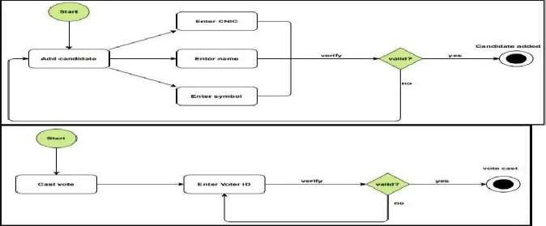

**Figure:5.2.4 State diagram**

### EXPLANATION:

State diagrams are loosely defined diagrams to show workflows of stepwise activities and actions, with support for choice, iteration, and concurrency. State diagrams require that the systemdescribed is composed of a finite number of states; sometimes, this is indeed the case, while at other times this is a reasonable abstraction. Many forms of state diagrams exist, which differ slightly and have different semantics.

### ACTIVITY DIAGRAM

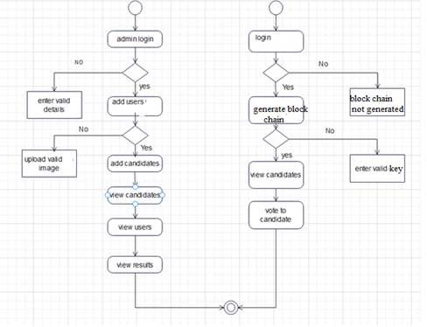

**Figure:5.2.5 Activity diagram**

### EXPLANATION:

Activity diagrams are graphical representations of workflows of stepwise activities and actions with support for choice, iteration and concurrency. In the Unified Modeling Language, activity diagrams can be used to describe the business and operational step-by-step workflows of components in a system. An activity diagram shows the overall flow of control.

### SEQUENCE DIAGRAM

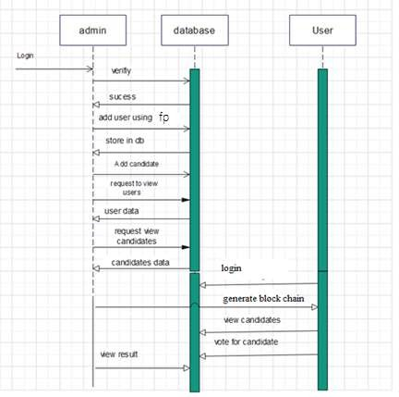

**Figure:5.2.6 Sequence diagram**

### EXPLANATION:

A sequence diagram in Unified Modeling Language (UML) is a kind of interaction diagram that shows how processes operate with one another and in what order. It is a construct of a Message Sequence Chart. Sequence diagrams are sometimes called event diagrams, event scenarios, and timing diagrams.

### COLLABORATION DIAGRAM

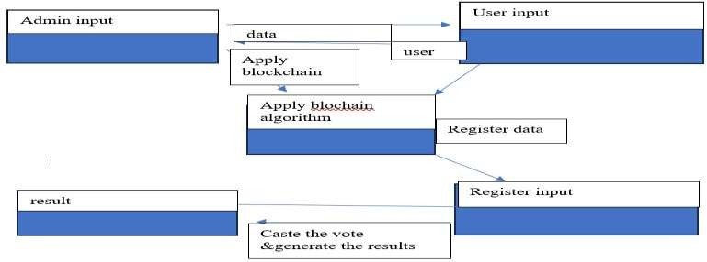

**Figure:5.2.7 Collaboration diagram**

### EXPLANATION

A collaboration diagram, also called a communication diagram or interaction diagram, is anillustration of the relationships and interactions among software objects in the Unified Modeling Language (UML). The concept is more than a decade old although it has been refinedas modelling paradigms have evolved.

* + 1. **COMPONENT DIAGRAM**

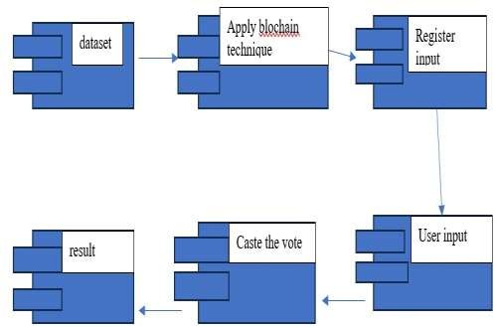

**Figure:5.2.8 Component diagram**

**EXPLANATION**

In the Unified Modeling Language, a component diagram depicts how components are wiredtogether to form larger components and or software systems. They are used to illustrate the structure of arbitrarily complex systems. User gives the main query and it is converted into sub queries and sent through data dissemination to data aggregators. Results are to be shown to users by data aggregators. All boxes are components and an arrow indicates dependencies.

## DEPLOYMENT DIAGRAM

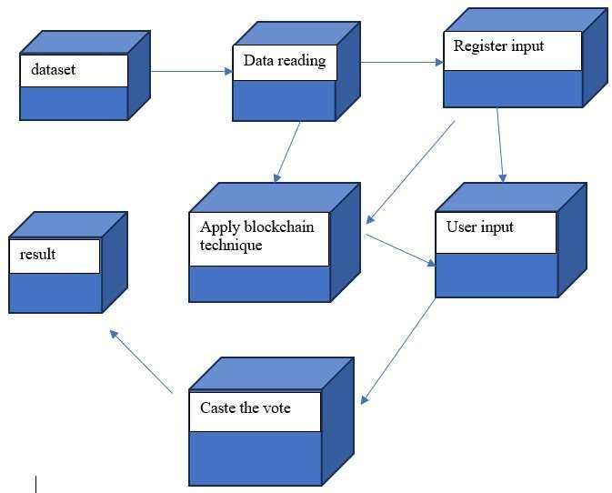

**Figure:5.2.9 Deployment diagram**

**EXPLANATION**

Deployment Diagram is a type of diagram that specifies the physical hardware on which

the software system will execute. It also determines how the software is deployed on the underlying hardware. It maps software pieces of a system to the device that is going to execute.

# CHAPTER 6 DEVELOPMENT TOOLS

### PYTHON

Python is a high-level, interpreted, interactive, and object-oriented scripting language. Python is designed to be highly readable. It uses English keywords frequently where as other languages usepunctuation, and it has fewer syntactical constructions than other languages.

### HISTORY OF PYTHON

Python was developed by Guido van Rossum in the late eighties and early nineties at the NationalResearch Institute for Mathematics and Computer Science in the Netherlands.

Python is derived from many other languages, including ABC, Modula-3, C, C++, Algol-68, Smalltalk, Unix shell, and other scripting languages.

Python is copyrighted. Like Perl, Python source code is now available under the GNU General Public License (GPL).

Python is now maintained by a core development team at the institute, although Guido van Rossum still holds a vital role in directing its progress.

### IMPORTANCE OF PYTHON

* + **Python is Interpreted** − Python is processed at runtime by the interpreter. You do notneed to compile your program before executing it. This is similar to PERL and PHP.
  + **Python is Interactive** − You can sit at a Python prompt and interact with the interpreter directly to write your programs.
  + **Python is Object-Oriented** − Python supports an Object-Oriented style or technique of programming that encapsulates code within objects.
  + **Python is a Beginner's Language** − Python is a great language for beginner-level programmers and supports the development of a wide range of applications.

###  FEATURE OF PYTHON

* + **Easy-to-learn** − Python has few keywords, a simple structure, and a clearly defined syntax. This allows the student to pick up the language quickly.
  + **Easy-to-read** − Python code is more clearly defined and visible to the eyes.
  + **Easy-to-maintain** − Python's source code is fairly easy-to-maintain.
  + **A broad standard library** − Python's bulk of the library is very portable and cross- platform compatible on UNIX, Windows, and Macintosh.
  + **Interactive Mode** − Python has support for an interactive mode which allows interactive testing and debugging of snippets of code.
  + **Portable** − Python can run on a wide variety of hardware platforms and has the same interface on all platforms.
  + **Extendable** − You can add low-level modules to the Python interpreter. These modules enable programmers to add to or customize their tools to be more efficient.
  + **Databases** − Python provides interfaces to all major commercial databases.
  + **GUI Programming** − Python supports GUI applications that can be created and ported to many system calls, libraries, and Windows systems, such as Windows MFC, Macintosh,and the X Window system of Unix.
  + **Scalable** − Python provides a better structure and support for large programs than shell scripting.

**Apart from the above-mentioned features, Python has a big list of good features, few are listedbelow −**

* + It supports functional and structured programming methods as well as OOP.
  + It can be used as a scripting language or can be compiled to byte-code for building largeapplications.
  + It provides very high-level dynamic data types and supports dynamic type checking.
  + IT supports automatic garbage collection.

### 6.5 LIBRARIES USED IN PYTHON

* + numpy - mainly useful for its N-dimensional array objects.
  + pandas - Python data analysis library, including structures such as data frames.
  + matplotlib - 2D plotting library producing publication quality figures.
  + sci-kit-learn - the machine learning algorithms used for data analysis and data miningtasks.

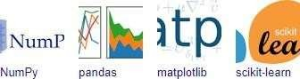

**Figure:6.5 NumPy, Pandas, Matplotlib, Scikit-learn**

# CHAPTER 7

* 1. **GENERAL**

# SOFTWARE TESTING

The purpose of testing is to discover errors. Testing is the process of trying to discover every conceivable fault or weakness in a work product. It provides a way to check the functionalityof components, sub-assemblies, assemblies and/or a finished product It is the process of exercisingsoftware with the intent of ensuring that the Software system meets its requirements and user expectations and does not fail in an unacceptable manner.

## DEVELOPMENT METHODOLOGIES

The test process is initiated by developing a comprehensive plan to test the general functionality and special features on a variety of platform combinations. Strict quality control procedures are used. The process verifies that the application meets the requirements specified in the system requirements document and is bug free. The following are the considerations used to develop the framework from developing the testing methodologies.

## TYPES OF TESTING

### Unit Testing:

In the process of Unit testing, we try to test the application by testing the units of the application or we could say the modules. The complete application is divided into different sets of Modules and each module is hence tested separately in order to scan out even the smallest possible error in the application. This is also commonly known as module testing.

### Specification Testing:

Executing this specification starting what the program should do and how it should performed under various conditions. Test cases for various situations and combination of conditions in all the modules are tested.

### System testing:

System testing is a process where the Complete and integrated software is tested for any errors. It is a type of black box testing technique is tested as a whole.

# CHAPTER 8 IMPLEMENTATION

### GENERAL

This project is implemented like an application using Python and the Server process is maintained using the SOCKET & SERVERSOCKET and the Design part is played by CascadingStyle Sheet.

* 1. **SAMPLE CODING**

from hashlib import sha256 import json

import time import pickle

from datetime import datetime import random

import pyaes, pbkdf2, binascii, os, secrets import base64

class Block:

def init (self, index, transactions, timestamp, previous_hash):

self.index = index self.transactions = transactions self.timestamp = timestamp self.previous_hash = previous_hash self.nonce = 0

def compute_hash(self):

block_string = json.dumps(self. dict , sort_keys=True) return sha256(block_string.encode()).hexdigest()

class Blockchain:

# difficulty of our PoW algorithm

difficulty = 2 #using difficulty 2 computation

def init (self): self.unconfirmed_transactions = [] self.chain = [] self.create_genesis_block() self.peer = []

self.translist = []

def create_genesis_block(self): #create genesis block

genesis_block = Block(0, [], time.time(), "0") genesis_block.hash = genesis_block.compute_hash() self.chain.append(genesis_block)

@property

def last_block(self): return self.chain[-1]

def add_block(self, block, proof): #adding data to block by computing new and previous hashes

previous_hash = self.last_block.hash

if previous_hash != block.previous_hash: return False

if not self.is_valid_proof(block, proof): return False

block.hash = proof #print("main "+str(block.hash)) self.chain.append(block) return True

def is_valid_proof(self, block, block_hash): #proof of work return (block_hash.startswith('0' * Blockchain.difficulty)

and block_hash == block.compute_hash())

def proof_of_work(self, block): #proof of work block.nonce = 0

computed_hash = block.compute_hash() while not computed_hash.startswith('0' *

Blockchain.difficulty):

block.nonce += 1

computed_hash = block.compute_hash() return computed_hash

def add_new_transaction(self, transaction): self.unconfirmed_transactions.append(transaction)

def addPeer(self, peer_details): self.peer.append(peer_details)

def addTransaction(self,trans_details): #add transaction self.translist.append(trans_details)

def mine(self):#mine transaction

if not self.unconfirmed_transactions: return False

last_block = self.last_block new_block = Block(index=last_block.index + 1

# SNAPSHOTS

### Home page:

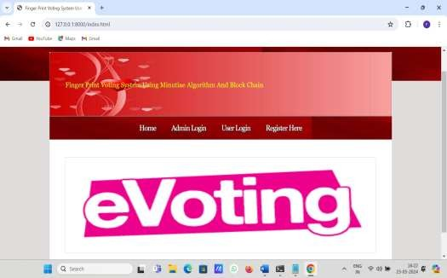

**Figure:8.3.1 Home page diagram**

### Register Page

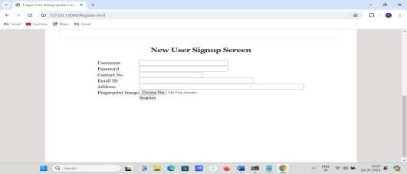

**Figure:8.3.2 Register page diagram**

### login page

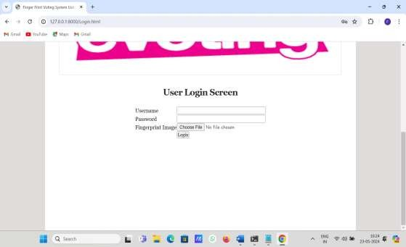

* + 1. **caste the vote**

**Figure:8.3.3 Login page diagram**

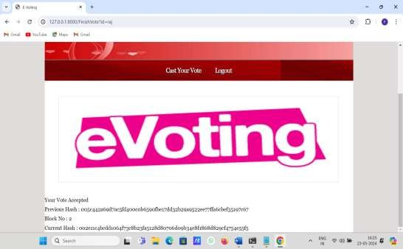

**Figure:8.3.4 caste vote diagram**

# CHAPTER 9

## APPLICATIONS & FUTURE ENCHANCEMENT

* 1. **GENERAL**

In order to effectively design and develop a system, it is important to understand and document the requirements of the system. The process of gathering and documenting the requirements of a system is known as requirement analysis. It helps to identify the goals of the system, the stakeholders, and the constraints within which the system will be developed. The requirements serve as a blueprint for the development of the system and provide a reference point for testing and validation.

## APPLICATIONS

1. **Achieve economies of scale** – increase volume output or productivity with fewer people. Your cost per unit, project or product plummets.
2. **Reduce spending on technology infrastructure.** Maintain easy access to your information with minimal upfront spending. Pay as you go (weekly, quarterly or yearly), based on demand.
3. **Globalize your workforce on the cheap.** People worldwide can access the cloud, provided they have an Internet connection.
4. **Streamline processes.** Get more work done in less time with less people.
5. **Reduce capital costs.** There’s no need to spend big money on hardware, software or licensing fees.
6. **Improve accessibility.** You have access anytime, anywhere, making your life so much easier!

## FUTURE ENCHANCEMENT

The present study is based on the use of only one module. In the future, we interface a few more modules that will use a few more biometrics for more authenticity and verification for the user like Iris Scanner.

For the security of our system, we will implement Block Chain to ensure all the copies of the database are the same and the network is doing constant checks. The data structure which is used blockchain is only appended. So, the data cannot be altered or deleted from any individual. The transactions are set in sequential or the chronological order.

# CONCLUSION

The proposed system will be designed to provide secure data and a trustworthy Evoting amongst the people of the democracy. Blockchain itself has been used in the voting system known as the decentralized blockchain system. By adopting finger print based login and block chain in the distribution of databases on E voting systems one can reduce the cheating sources of database manipulation. This project aims to implement voting result using block chain algorithm from every place of election.

The proposed Fingerprint based voting system which is better and faster than the previous system. The new system prevents access to illegal voters, provides ease of use, transparency and maintains the integrity of the voting process. The system also solves the problem of RIGGING, means it does not allows a user to vote multiple times since his fingerprint is recorded once in an election. The system does not allow the voter to vote for more than once in the same election.

# REFERENCES:

1. N. Kshetri and J. Voas, “Blockchain-Enabled E-Voting,” IEEE Software, vol. 35, pp. 95-99, Jul 2018.
2. M. Pawlak, J. Guziur, and A. Poniszewska-Mara nda, “Voting Processwith Blockchain Technology: Auditable Blockchain Voting System,” inLecture Notes on Data Engineering and Communications Technologies,pp. 233-244, Springer, Cham, 2019.
3. B. Singhal, G. Dhameja, and P. S. Panda, “How Blockchain Works,” inBeginning Blockchain, pp. 31-148, Berkeley, CA: Apress, 2018.
4. Agora, “Agora Whitepaper,” 2018.
5. R. Perper, “ Sierra Leone is the first country to use blockchain duringan election - Business Insider,” 2018.
6. S. Nakamoto, “Bitcoin: A Peer-to-Peer Electronic Cash System,” tech.rep., 2008.
7. G. Wood et al., “Ethereum: A secure decentralised generalised transaction ledger,” Ethereum project yellow paper, vol. 151, pp. 1-32, 2014.
8. S. Landers, “Netvote: A Decentralized Voting Platform - Netvote Project Medium,” 2018.
9. P. McCorry, S. F. Shahandashti, and F. Hao, “A Smart Contract for Boardroom Voting with Maximum Voter Privacy,” inLecture Notes in Computer Science, ch. FCDS, pp. 357-375, Springer, Cham, 2017.
10. Z. Brakerski and V. Vaikuntanathan, “Efficient Fully Homomorphic Encryption from (Standard)LWE,” SIAM Journal on Computing, vol.43,pp. 831-871, jan 2014.